GOVERNMENT OF ARTS AND SCIENCE COLLEGE, C.MUTLUR, CHIDAMBARAM – 608 102



DEPARTMENT OF COMPUTER SCIENCE

MACHINE LEARNING

*Project Title: Flight Delay Prediction for aviation industry*

*Using machine learning*

Team ID: NM2023TMID23521

Team Leader: HARISH.S

Team Member: GOBALAKRISHNAN.K

Team Member: JANAKI.N

Team Member: HEMASATHIYA.J

Overview:

* The flight delay prediction project using machine learning involves the development of a model that can accurately predict flight delays. This project utilizes historical flight data and machine learning techniques to identify patterns and factors that contribute to flight delays.
* The model is trained on a large dataset of flight information, which includes various features such as departure and arrival times, weather conditions, airline and airport operations, and other relevant factors that may impact flight delays.
* Once the model is trained, it can be used to predict the likelihood and duration of flight delays for future flights. This information can be used by airlines and passengers to better plan their travel schedules, reduce the impact of flight delays, and improve overall flight efficiency.
* The project aims to improve the accuracy of flight delay predictions by utilizing advanced machine learning techniques such as neural networks and decision trees. By doing so, the model can identify complex relationships and interactions between various factors that may impact flight delays.
* Overall, the flight delay prediction project using machine learning has the potential to greatly improve the efficiency and reliability of air travel by providing more accurate and timely information on flight delays.

Purpose :

* Improving airline operations: By accurately predicting flight delays, airlines can better manage their resources, such as gate assignments, crew scheduling, and aircraft utilization. This can lead to improved efficiency and cost savings for airlines.
* Enhancing customer experience: Accurate flight delay predictions can help airlines to proactively communicate with customers about potential delays and provide alternative travel options. This can help to reduce stress and frustration for travelers, improving their overall experience .
* Increasing safety: Machine learning models can be used to predict potential safety hazards, such as adverse weather conditions, which could impact flight operations. By identifying these hazards in advance, airlines can take appropriate safety measures to protect passengers and crew.
* Supporting airport planning: Flight delay prediction can help airports to better manage their operations and resources, such as ground handling and gate assignments. This can lead to improved efficiency and reduced congestion at airports.

**PROBLEM DEFINING & DESIGN THINKING**

Empathy map:

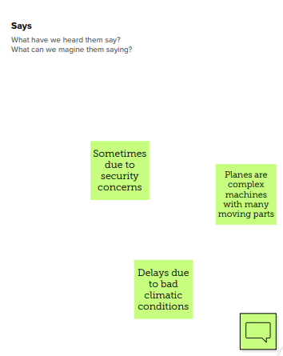 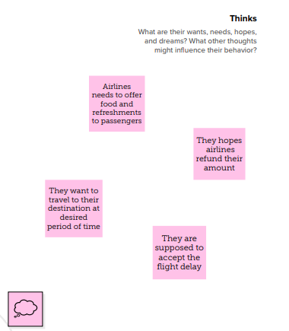

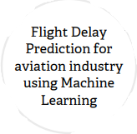

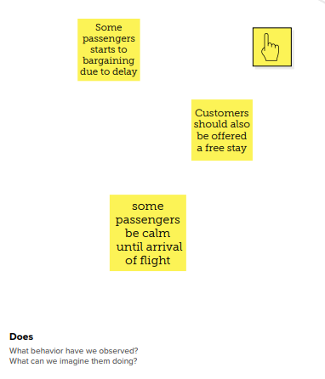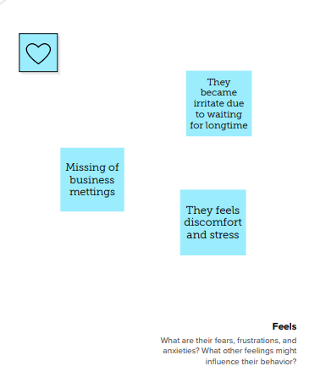

**IDEATION & BRAINSTORMING METHODS**

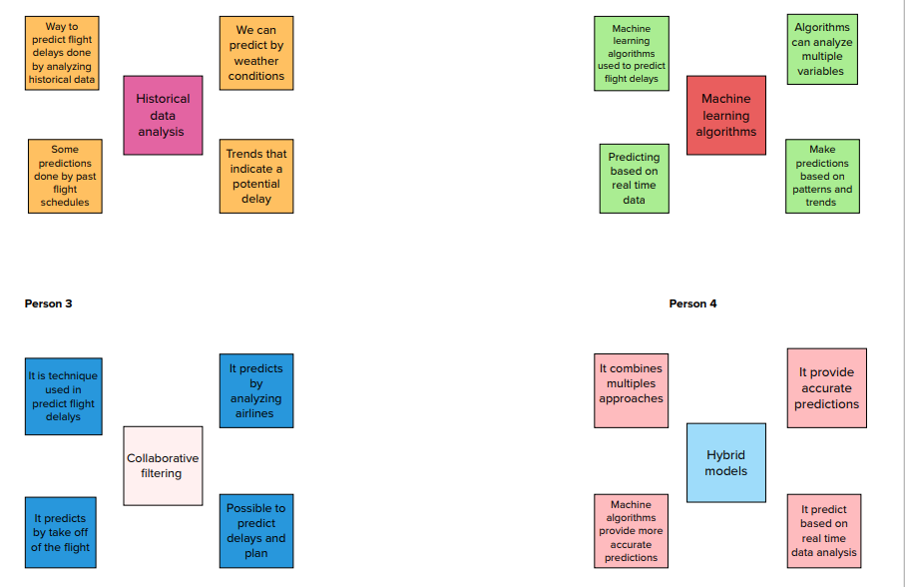

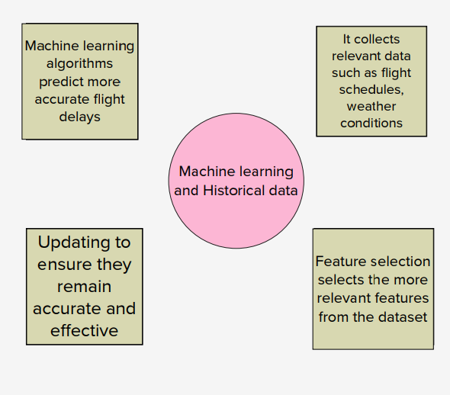

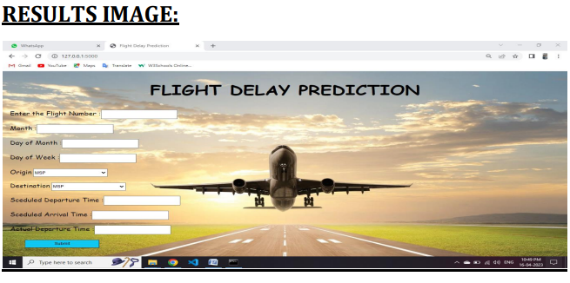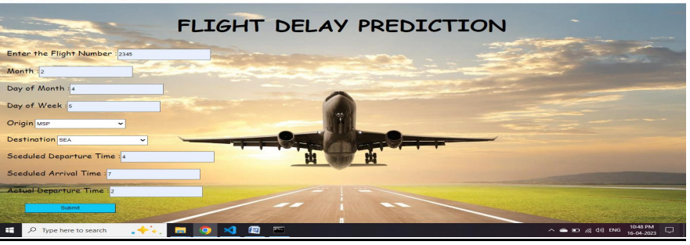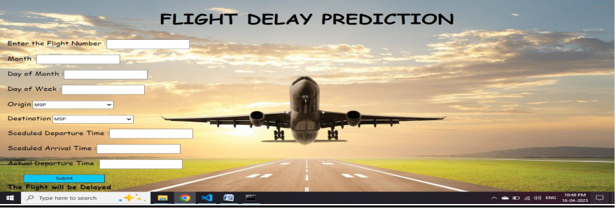

**Advantages of flight delay:**

* Reimbursement of your ticket and a return flight to your departure airport if you have a connecting flight.
* Rerouting to your final destination.
* Rerouting at a later date under comparable transportation conditions.
* When we traveling by air, can sit comfortable in an armchair, reading magazines, listen to music, read books, play games or watching a free film on television.

**Disadvantages of flight delay:**

* Flight delays not only irritate air passengers and disrupt their schedules but also cause a decrease in efficiency, an increase in capital costs, reallocation of flight crews and aircraft, and additional crew expenses.
* There are plane crashes in which the crew and passengers have died.
* Airports can often be several miles from city center.

**Applications for Flight Delay:**

* It is widely used by aircraft operators throughout the world to inform and facilitate corrective actions in a range of operational areas by offering the ability to track and evaluate flight operations trends, identify risk precursors, and take the appropriate remedial action. ⎫
* Therefore, predicting flight delays can improve airline operations and passenger satisfaction, which will result in a positive impact on the economy. In this study, the main goal is to compare the performance of machine learning classification algorithms when predicting flight delays.
* With predictive analytics, sensory equipment gathers information from each aircraft's systems, and sends that information to a cloud. That data is then analyzed and used to determine everything from fleet maintenance schedules to marketing strategies.
* In case of a delay of over 24 hours, the passenger should be offered free hotel accommodation.
* Customers should also be offered a free stay if a flight departs between 8 pm and 3 am and is delayed for over six hours

**Conclusion:**

* In this project, we use flight data, weather, and demand data to predict flight departure delay. Our result shows that the Random Forest method yields the best performance compared to the SVM model.
* Somehow the SVM model is very time consuming and does not necessarily produce better results. In the end, our model correctly predicts 91% of the non-delayed flights.
* However, the delayed flights are only correctly predicted 41% of time. As a result, there can be additional features related to the causes of flight delay that are not yet discovered using our existing data sources.
* In the second part of the project, we can see that it is possible to predict flight delay patterns from just the volume of concurrently published tweets, and their sentiment and objectivity.
* This is not unreasonable; people tend to post about airport delays on Twitter; it stands to reason that these posts would become more frequent, and more profoundly emotional, as the delays get worse. Without more data, we cannot make a robust model and find out the role of related factors and chance on these results.
* However, as a proof of concept, there is potential for these results. It may be possible to routinely use tweets to ascertain an understanding of concurrent airline delays and traffic patterns, which could be useful in a variety of circumstances

.

**Future scope:**

* + This project is based on data analysis from year 2008. A large dataset is available from 1987-2008 but handling a bigger dataset requires a great amount of preprocessing and cleaning of the data.
  + Therefore, the future work of this project includes incorporating a larger dataset. There are many different ways to preprocess a larger dataset like running a Spark cluster over a server or using a cloud-based services like AWS and Azure to process the data.
  + With the new advancement in the field of deep learning, we can use Neural Networks algorithm on the flight and weather data. Neural Network works on the pattern matching methodology. It is divided into three basic parts for data modelling that includes feed forward networks, feedback networks, and self organization network.

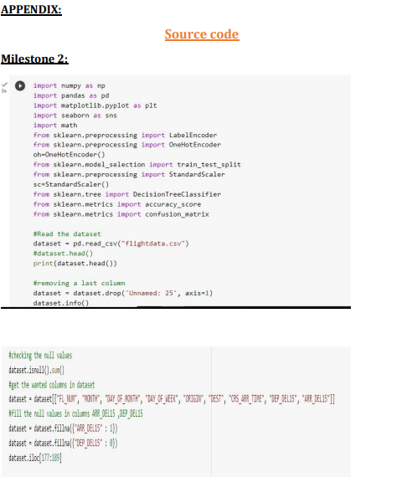

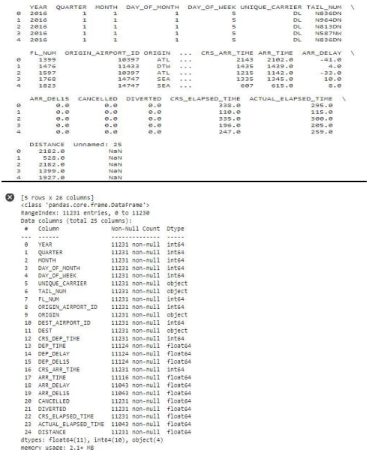

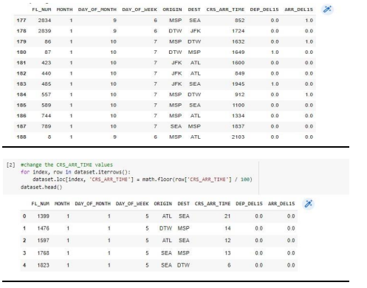

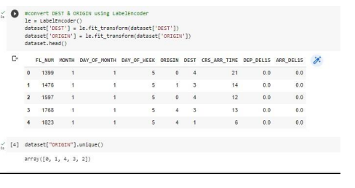

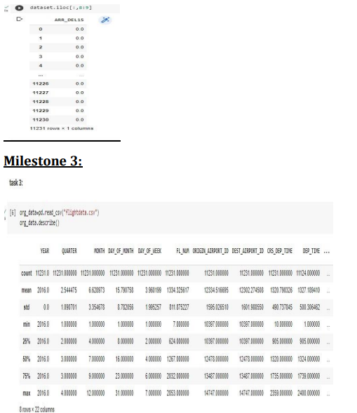

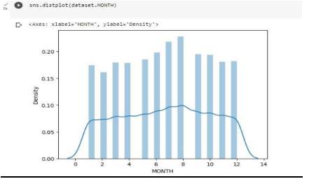

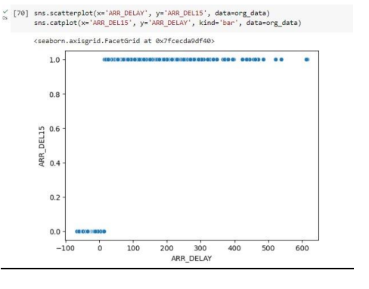

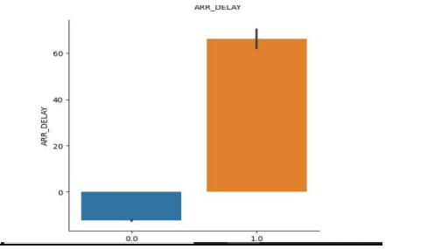

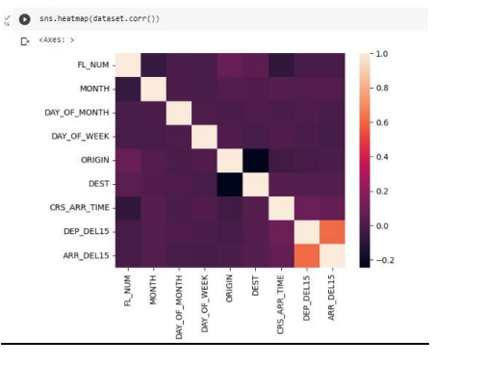

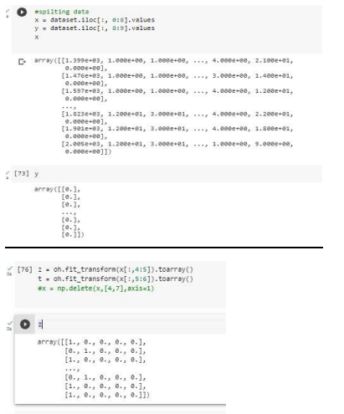

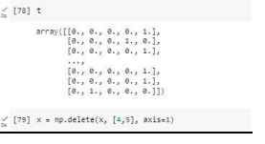

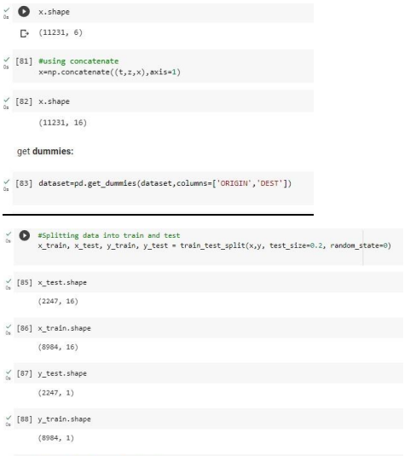



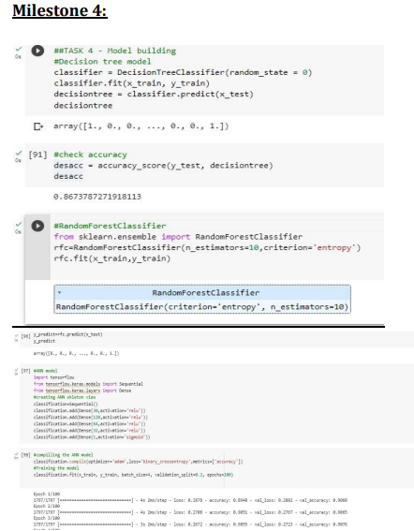

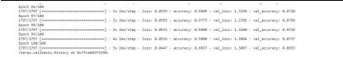

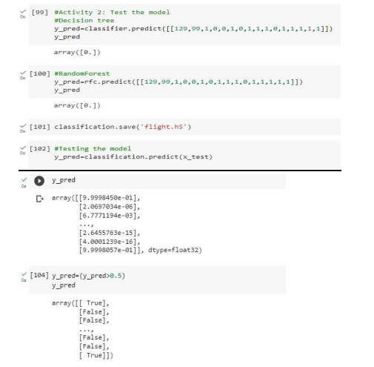

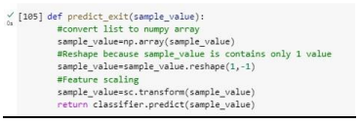

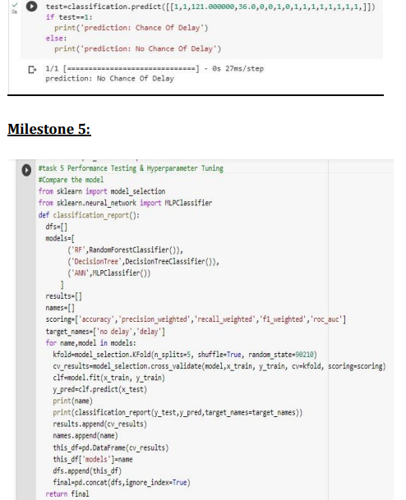

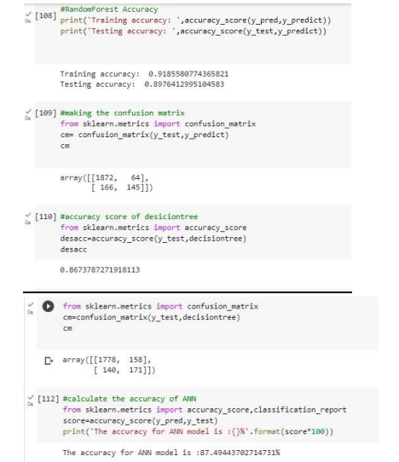

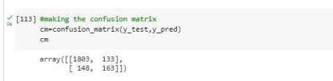

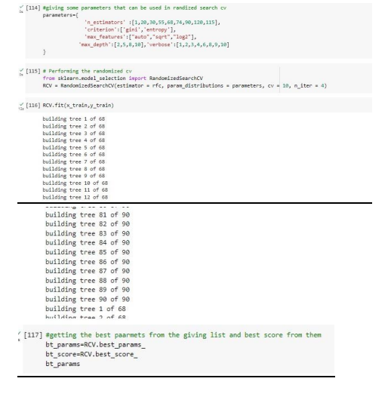

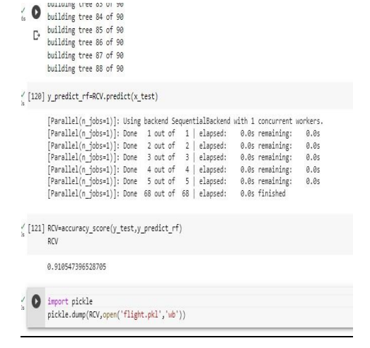

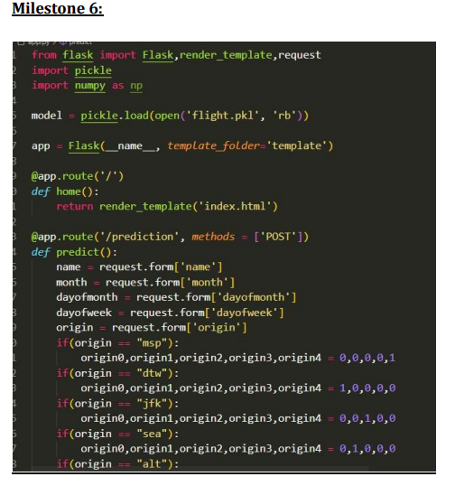

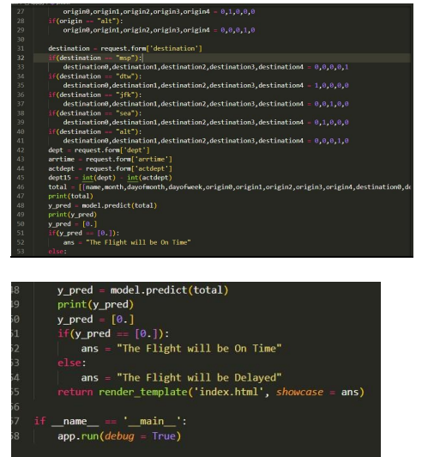

**USER INTERFACE WEB PAGE CODE:**

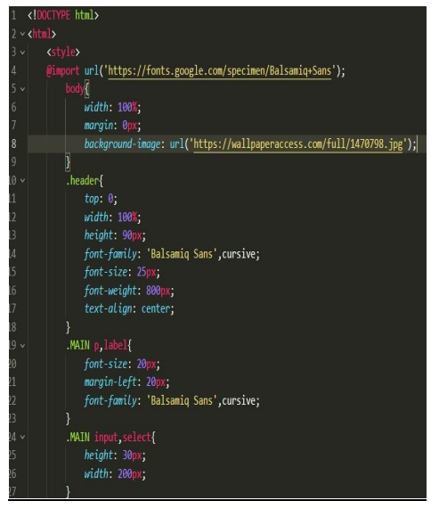

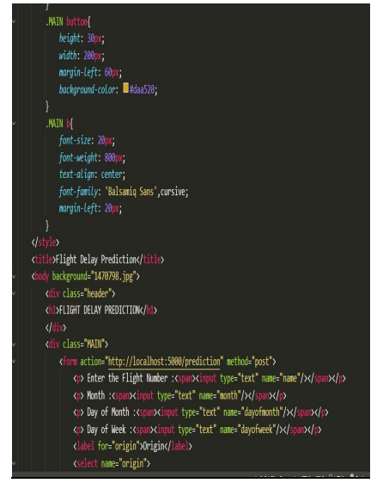

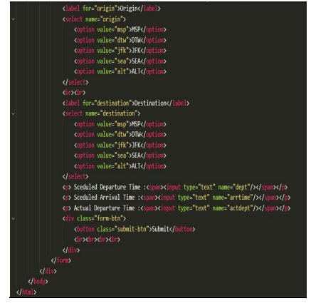

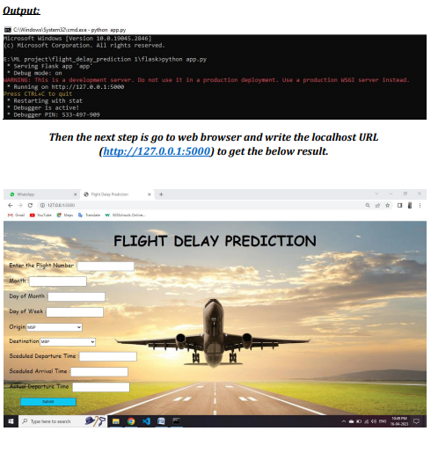

The user will give input to get the predicted result after clicking the submit button

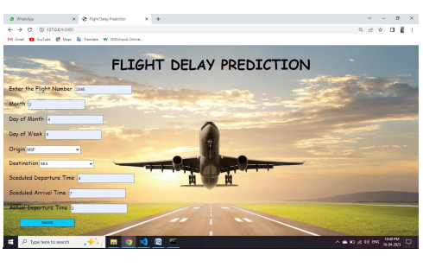

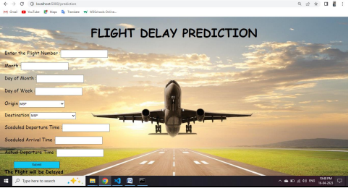

**THANK YOU**